**Variable length arguments is the best practice when we do not know how many arguments will be provided**

**As name says the length of the argument is not fixed, it varies**

here is the example

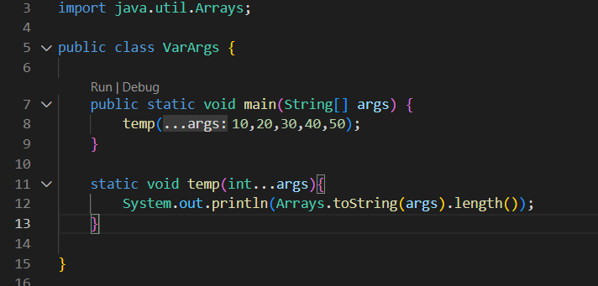

We do have two rules here

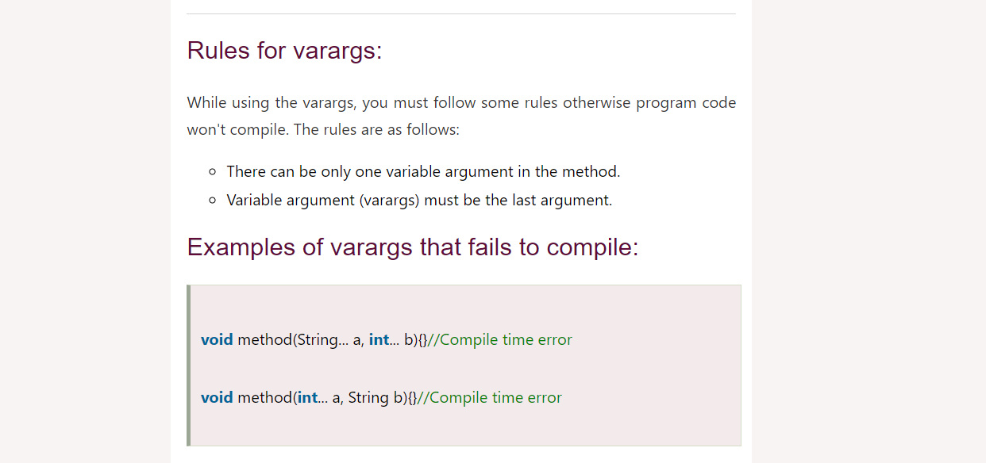

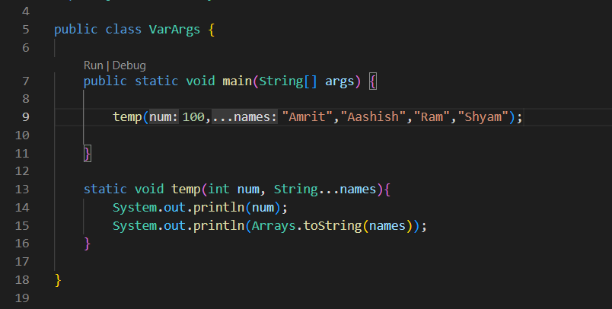

Here

1. There is only one varargs
2. Varargs is the last argument

Also by default the varargs pass are stored in the array